광운대학교

**객체지향프로그래밍**

Assignment 1

제출일자: 2018년 03월 30일 (금)

학 과: 컴퓨터공학과

담당교수: 김영민 교수님

학 번: 2014722075

성 명: 이동준

**<1> Collatz conjecture**

1. Question & Explanation

Question is that write program “If Ai is even, Ai+1 is Ai/2. But, if Ai is odd, Ai+1 is 3Ai +1.” and if output is 1 during process, program will end. This program is called Collatz conjecture. Need to display all of number in process, count, the maximum, minimum, and sum, average. After input n, we can see process, count, max, min, sum, average. If input not number, output is Error : please enter number!.

1. Result

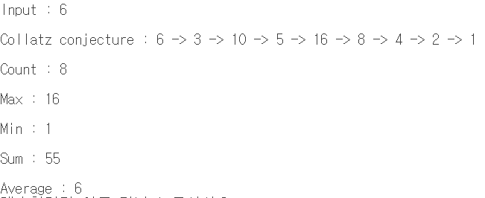

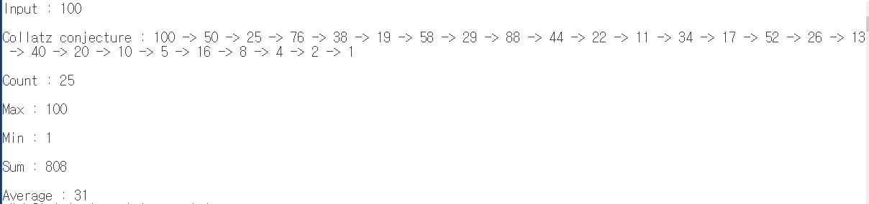

- To solve this Question, have to know “if else”. And to find count, max, min, sum, average, need to know basic Comparison. And make program to end if result is 1. So maybe always last result is 1

**<2> Make star using Mark**

1. Question & Explanation

Question is that using C++ loops, make star with Mark. First input mark, and input N that is length of one side of star. we need to input(n) odd number from 3 to 11. i write program by using loops(for) and I separate 3 part(first top triangle, middle trapezoid, bottom 2 triangle). If input even number, output is Error : please enter even number!.

1. Result

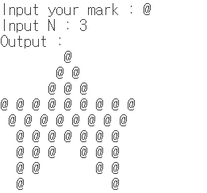

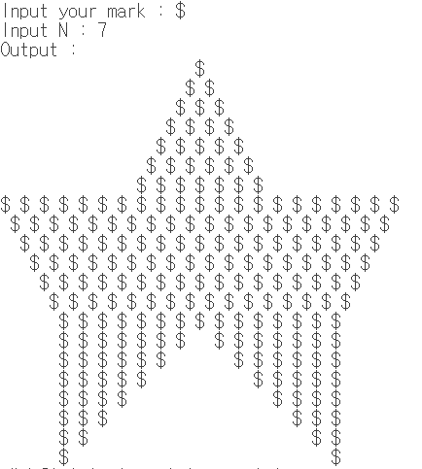

- To solve this Question, need to make good use of “for”. And have to grasp the rules in star

**<3> Perfect number**

1. Question & Explanation

Question is that find perfect number from 1 to n(input integer). Perfect number is that if the sum of its factors is equal to the number, it is perfect number! If find perfect number, need to print the factors of each perfect number.

1. Result

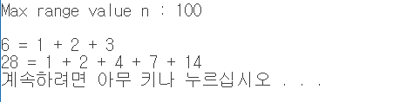

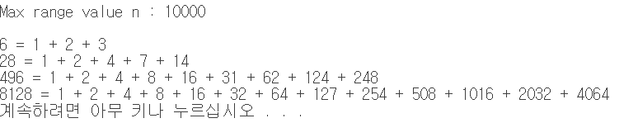

- to solve this Question, need to know perfect number. Together, know that How to obtain a divisor

**<4> InsertString**

1. Question & Explanation

Question is that second input string(str2) insert in want position(n) of first input string(str1). Need to change str1 with str2. If n is bigger than length of str1, print Error!. I use another function that insert str2 in str1. str1 is changed using str3 in function. Copy str1 to str3 from str1[0] to str1[n-1], copy str2 to str3 from str2[0] to end of str2. Finally copy str1 to str3 from str1[n] to end of str1.

1. Result

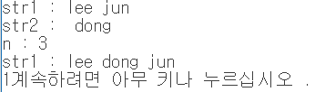

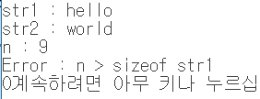

- To solve this Question, I must know string copy and detailed behavior in “for”

**<5> Messi and Candle**

1. Question & Explanation

Question is that Messi have cake and he will blow out the candles. But he can blow out only one candle that tallest ones. So need to tallest candle(s) and count tallest candle(s). Input is Messi’s age, Heights of candles. Output is the number of candles that Messi blows out. I use Bubble sorting for counting tallest candle(s). If input age is 1 > age or age < 10000, print Error : not age. If input heights of candles are 1 > heights or heights < 1000, print Error : candle heights.

1. Result

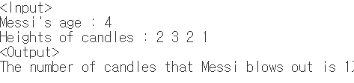

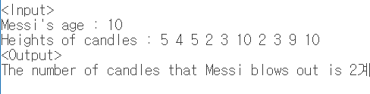

- To solve this Question, have to know sorting(my case). And copy way to another char variable.

**\* Consideration**

I am restudying student, so I need A0 grade. When I was 2nd grade, I should have mistaken middle and final exam. Now I am 3rd grade, no second mistake. First i think that this assignment 1 is easier than when I was 2nd grade. So I can complete this assignment. I used loops(for, while) in this assignment. I used it frequently when I was 2-2 grade in data Structure.

However, the str function was not available and it was somewhat difficult. Specially in <4>, I had to run a new algorithm. Like this times, Based on experience, I want to complete this programing